Updating Velocity Products themselves, simply download the product file from the [upload/download section of the Velocity service webpage](https://velocitysoftware.com/customer/ftpv4.cgi). You will need the last version ending in 0 as well as the latest/highest version.  
For example: 5110 and 5111, rather than just 5111. Versions ending in 0 contain the base file information whereas any other digit contains changes and updates to the base. See, “FTPing How To” instructions for detailed steps on performing file transfers with zVM.

Color Coding Key:

* Purple segments are COMMANDS.
* Red segments are user/circumstance/device supplied values.
* Blue segments are options and operands of the command.  
  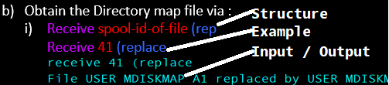

1. Once downloaded, copy the file location path to the folder containing them.
   1. 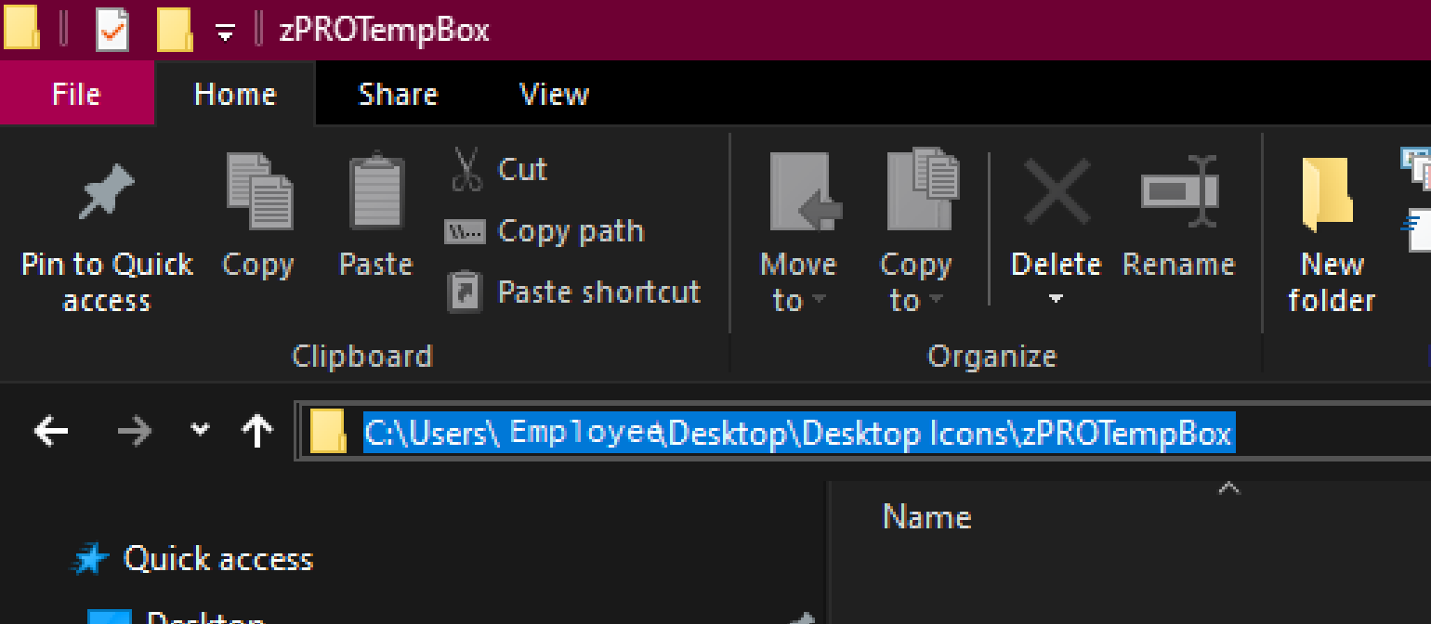
2. Ftp the files onto a zVM user whose mdisk can be accessed and fit the files. Follow my FTPing instructions if it’s your first time doing an FTP to or from zVM.
   1. Start the FTP session with your z/VM host:   
      ftp *options ipaddress*  
      **ftp -i** *xx.x.xx.xxx*  
      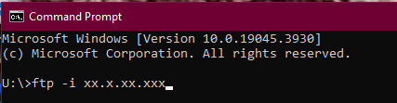
   2. Enter the z/VM user ID that can access the minidisk in write mode and the password for that ID:  
      Username  
      JORDAN  
      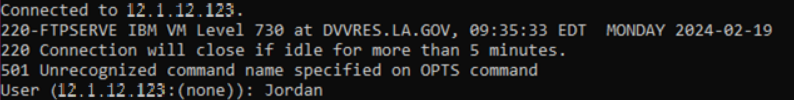  
      **password  
      xxxxxxx**  
      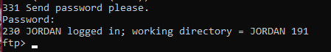
   3. Change the working directory on your z/VM host to the minidisk where you want to load the files (note that there is a period between the user ID and minidisk address):  
      cd zVMdirectorypath  
      **cd** JORDAN.191  
      
   4. Set the Local Directory to the Windows Desktop folder location containing the files you intend to FTP or the destination folder for the files you’re FTPing from zVM.  
      lcd desktopfolderpath  
      **lcd** C:\Users\P00341017\Desktop\zPROTempBox  
      
   5. Set the file transfer mode to binary and the record format and length to fixed 1028:  
      binary  
      **binary**  
      
   6. Set the file transfer size to 1028 bytes. (Logical Record Length, AKA Lrecl)  
      quote site fixrec recordlength  
      **quote site fixrec 1028**  
      
   7. Put the installation files on the z/VM minidisk:  
      **mput** file **mput *.PROD5**\*  
      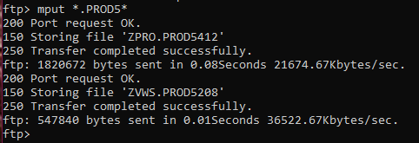
      1. All of the files in the directory that contain, “.PROD5”will now start to transfer. This could take some time, depending on the speed of your connection. For video walkthrough see, “zVM 7.3 FTP” within Reference Materials>Examples>FTP.
3. Log onto the ZVPS user within the system you intend to update and open the installation manager VSIMAINT by typing and submitting the command VSIMAINT.  
   
4. Link to the user holding the version files within zVM. (ex. VMLINK JORDAN 191)
   1. Link to the user containing the update files.  
      VMLINK User Mdisk  
      VMLINK JORDAN 191  
      
5. Copy the files to ZVPS’s A disk, perform this step however many times necessary replacing the filename, type and mode as appropriate.  
    (ex. Copyfile zvws PROD5108 z = = a)
   1. Copy the files.  
      Copyfile filename filetype filemode newFN newFT newFM  
      Copyfile syn synonym z = = a  
      
6. Open VSIMAINT from ZVPS and select the product you’re updating by tabbing or using the cursor to click on the new product’s version number (which should display as white.)  
   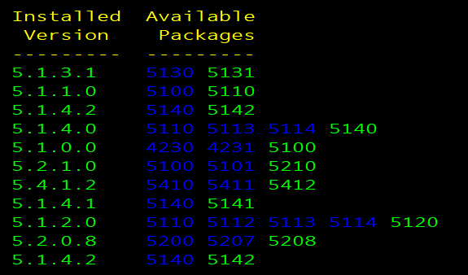
   1. Once in the new menu the installation option should by default be what is selected but if not select the Installation line by moving the cursor over it and clicking or navigating with arrow keys etc. To begin the install press F2 as shown at the bottom of the screen.  
      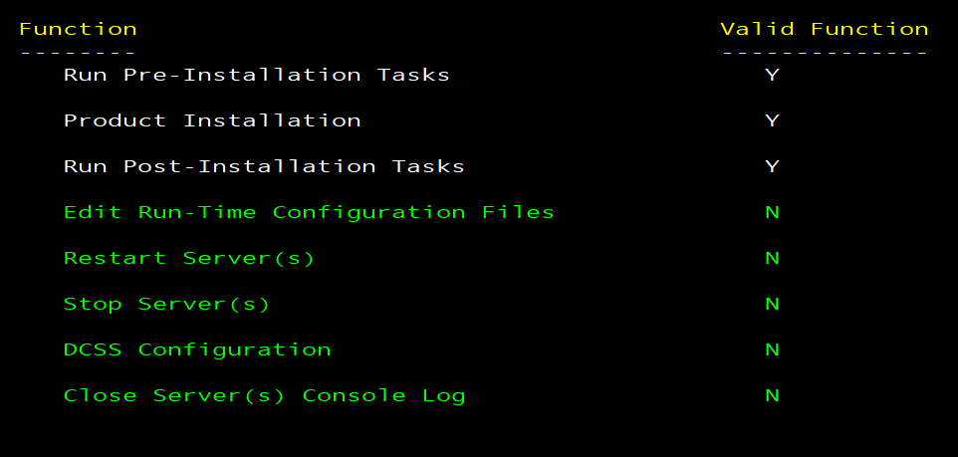  
      
7. Once the update has taken place and the correct version is shown as the current, if the version number is red restart the velocity suit zvws with the VSIMAINT RESTART ZVWS command. Output ideally will look something akin to the following, emphasis on receiving the last three white output lines:  
   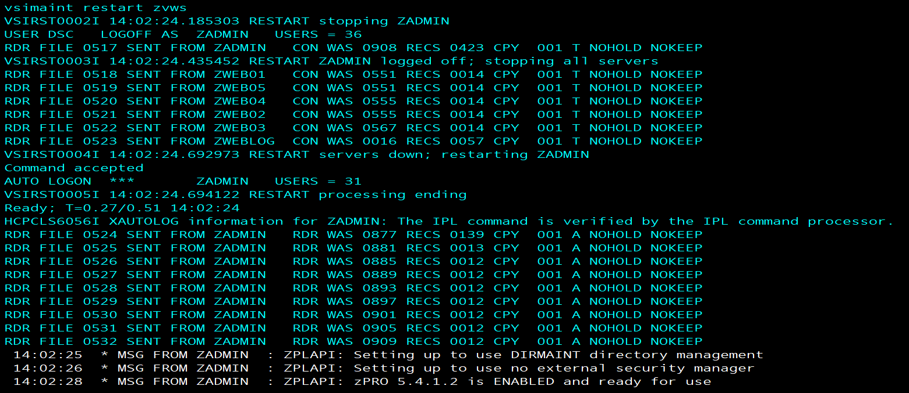  
     
     
   Updating the Velocity Key simply copy/paste the new key over the old as instructed via the yellow text in the VSIMAINT panel next to the key. PFKey 5 (F5) will apply the overwritten key and request a file be read for the expiration date. The key will take a few minutes to update the expiration time and should display a message saying as much if the date is not available immediately after input.  
   